I.

1. Because $X$ follows a discrete probability distribution that describes the probability of $X$ successes (positive cases) in $n$ draws (takes a more extensive PCR test), without replacement, from a finite population (the group that takes basic test) of size $N$ that contains exactly $K$ objects with that feature, where in each draw is either a success (positive) or a failure (negative).
$$P\left[X=x\right]= \frac{\left({K \atop x}\right)\left({N-K \atop n-x}\right)}{\left({N \atop n}\right)}, ∀x ∈ \{max\{0, n + K - N\}, . . . , min\{n, K\}\}$$

2. For a population of $N$, we test them one oy one, when the $i$-th person is tested positive, i.e. $k_{i}=1$, we increment $K$, the count of positive cases within these $N$ people. So $K=\sum_{i=1}^{N}{k_{i}}$.

For a population of $N$, we decide one oy one if choose them into the smaller group of $n$, when the $i$-th person is tested positive, i.e., $C_{i}=1$, we increment $n$, the size of the smaller group within these $N$ people. So $n=\sum_{i=1}^{N}{C_{i}}$.

For a population of $N$, we decide one oy one if choose them into the smaller group of $n$ and test them, when the $i$-th person is tested positive and he is chosen into smaller group, i.e., ${k_{i}C}_{i}=1$, we increment $X$, the count of positive cases within the smaller group of size $n$. So $X=\sum_{i=1}^{N}{{k_{i}C}_{i}}$.

$E\left[n\right]=E\left[\sum_{i=1}^{N}{C_{i}}\right]=\sum_{i=1}^{N}{{E[C}_{i}]=N{E[C}_{i}]}=n, ∴q={E[C}_{i}]=n/N$.

$E\left[K\right]=E\left[\sum_{i=1}^{N}{k_{i}}\right]=\sum_{i=1}^{N}{{E[k}_{i}]=N{E[k}_{i}]}=K, ∴{E[k}_{i}]=\frac{K}{N}$.

Since $C_{i}$ and $k_{i}$ are independent, $E\left[X\right]=E\left[\sum_{i=1}^{N}{{C_{i}k}_{i}}\right]=\sum_{i=1}^{N}{{E[C_{i}k}_{i}]=N{E\left[C_{i}\right]E[k}_{i}]}=K, ∴{E[k}_{i}]=np$.

1. . $K^{2}=(\sum_{i=1}^{N}{k_{i})}(\sum_{j=1}^{N}{k_{j})=\sum_{i=1}^{N}{{k_{i}}^{2}}}+\sum_{i≠j}{k_{i}k_{j}. ∵}∀i∈\left\{1,…,N\right\}, k_{i}∈\left\{0,1\right\}, ∴ ∀i∈\left\{1,…,N\right\}, k_{i}={k_{i}}^{2}.$

. $∴ K^{2}=\sum_{i=1}^{N}{k_{i}}+\sum_{i≠j}{k_{i}k_{j}=K+\sum_{i≠j}{k_{i}k_{j}}}$

. $n^{2}=(\sum_{i=1}^{N}{C_{i})}(\sum_{j=1}^{N}{C_{j})=\sum_{i=1}^{N}{{C_{i}}^{2}}}+\sum_{i≠j}{C_{i}C_{j}. ∵}∀i∈\left\{1,…,N\right\}, C_{i}∈\left\{0,1\right\}, ∴ ∀i∈\left\{1,…,N\right\}, C_{i}={C_{i}}^{2}.$

. $∴ n^{2}=\sum_{i=1}^{N}{C_{i}}+\sum_{i≠j}{C_{i}C_{j}=n+\sum_{i≠j}{C_{i}C_{j}}}$

$X^{2}=(\sum_{i=1}^{N}{{k_{i}C}_{i})}(\sum_{j=1}^{N}{{k_{j}C}_{j})=\sum_{i=1}^{N}{{k_{i}}^{2}{C_{i}}^{2}}}+\sum_{i≠j}{{k_{i}k_{j}C}_{i}C_{j}. ∵}∀i∈\left\{1,…,N\right\}, C_{i}∈\left\{0,1\right\},$

. $∴ ∀i∈\left\{1,…,N\right\}, {k_{i}C}_{i}={k_{i}}^{2}{C_{i}}^{2}. ∴ X^{2}=\sum_{i=1}^{N}{k_{i}C_{i}}+\sum_{i≠j}{{k_{i}k_{j}C}_{i}C_{j}=X+\sum_{i≠j}{{k_{i}k_{j}C}_{i}C_{j}}}$

**. $E\left[X\left(X-1\right)\right]=\sum_{x=0}^{n}{x\left(x-1\right)\frac{\left({K \atop x}\right)\left({N-K \atop n-x}\right)}{\left({N \atop n}\right)}}=\sum_{x=2}^{n}{\frac{K\left(K-1\right)\left({K-2 \atop x-2}\right)\left({N-K \atop n-x}\right)}{\frac{N\left(N-1\right)}{n\left(n-1\right)}\left({N-2 \atop n-2}\right)}=\frac{n\left(n-1\right)K\left(K-1\right)}{N\left(N-1\right)}}\sum_{x=2}^{n}{\frac{\left({K-2 \atop x-2}\right)\left({N-K \atop n-x}\right)}{\left({N-2 \atop n-2}\right)}}=\frac{n\left(n-1\right)K\left(K-1\right)}{N\left(N-1\right)}$**

. $=\frac{np(n-1)(pN-1)}{(N-1)}$

. $E\left[X^{2}\right]=E\left[X\left(X-1\right)\right]+E\left[X\right]=np+\frac{np(n-1)(pN-1)}{(N-1)}$

. $Var\left(X\right)=E\left[X^{2}\right]-{E\left[X\right]}^{2}=np+\frac{np\left(n-1\right)\left(pN-1\right)}{N-1}-n^{2}p^{2}=np\frac{N-1+\left(n-1\right)\left(pN-1\right)-\left(N-1\right)np}{N-1}=\frac{np(1-p)(N-n)}{N-1}$,

. $Var\left(X/n\right)=\frac{Var\left(X\right)}{n^{2}}=\frac{p(1-p)(N-n)}{n(N-1)}$



$∵0≤p\left(1-p\right)≤\frac{1}{2}*\frac{1}{2}=\frac{1}{4}, ∴Var\left(\frac{X}{n}\right)=p\left(1-p\right)\frac{N-n}{n\left(N-1\right)}≤ \frac{1}{4}\frac{N-n}{n\left(N-1\right)}.$

When $N=1322, n=1103,Var\left(X/n\right)=\frac{K(N-K)(N-n)}{N^{2}n(N-1)}=\frac{219K(1322-K)}{2,546,485,692,092}$.

1. According to Chebyshev inequality, $P\left[\left|\frac{X}{n}-p\right|≥c\right]≤\frac{Var\left(\frac{X}{n}\right)}{c^{2}}=0.05, ∴c=\sqrt{20Var(\frac{X}{n})}$

$P\left[p∈\left[A,B\right]\right]=P\left[\left|\frac{X}{n}-p\right|≤c\right]≥0.95→A=\frac{X}{n}-c, B=\frac{X}{n}+c.$

$.c=\sqrt{20Var(\frac{X}{n})}≈0.02705. ∴A≈0.55409, B≈0.60819$.

1. We use Markov Inequality on the nonnegative random variable ${\left(\frac{X}{n}-p\right)}^{4}$. $\left\{\left|\frac{X}{n}-p\right| ≥c\right\}→\left\{{(\frac{X}{n}-p)}^{4} ≥c^{4}\right\}, ∴P\left[\left|\frac{X}{n}-p\right|≥c\right]=P\left[{(\frac{X}{n}-p)}^{4} ≥c^{4}\right]≤\frac{E\left[{\left(\frac{X}{n}-p\right)}^{4}\right]}{c^{4}}=\frac{E\left[({\frac{1}{n})}^{4}{\left(X-np\right)}^{4}\right]}{c^{4}}=\frac{E\left[{\left(X-np\right)}^{4}\right]}{n^{4}c^{4}}$.

. $\frac{μ_{4}}{n^{4}c^{4}}=0.05→c=0.0168266, A≈0.56432, B≈0.59797$

1. Chernoff bound: for any $t∈[0,1-p]$ $.P[X≥(p+t)n]≤e^{-D_{KL}(p+t||p)n}$, where $D_{KL}(p+t||p)$ gives the relative entropy of $p+t$ and .

<https://arxiv.org/pdf/1507.08298> this paper also provides exponential bounds for hypergeometric distribution with previous studies mentioned.

II

1. Mean of $\frac{1}{j}\sum_{m=1}^{j}{\frac{X_{m}}{1103}}$ is 0.5809, variance is 3.1625e-08. $\frac{1}{j}\sum_{m=1}^{j}{\frac{X_{m}}{1103}}$ is an unbiased estimator of $p$. We want large $j$ due to Law of Large Numbers.

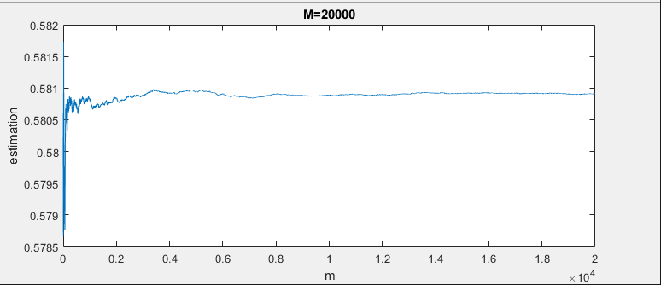

$\frac{1}{j}\sum_{m=1}^{j}{\frac{{X_{m}}^{2}}{{1103}^{2}}}=0.3375;E\left[\frac{{X_{m}}^{2}}{{1103}^{2}}\right]=0.3370$

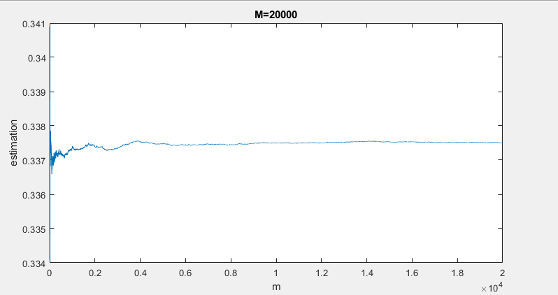

1. For this problem, the upper bound 0.05 is quite loose. Mean of $\frac{1}{j}\sum_{m=1}^{j}{1_{\{|\frac{X_{m}}{1103}-p|≥c\}}}$ is 0.0061, variance is 3.3888e-07.

